National Fire Plan - In Kind Dollars Year__________
Community Name:__________________________ | Landowner’s Name:_____________________________
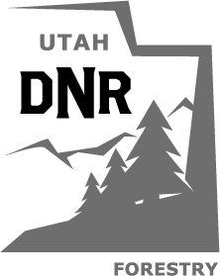

Print Name | Community or Lot # (if you have one) | Date | Hours Worked | Activity (Removing dead trees or brush, chipping debris, limbing-up trees, reducing fuel around cabin or home, clearing dry weeds) | Equipment Used Chainsaw, ATV, Truck, Backhoe, Tractor, Front-end Loader (or other motorized equipment) | Days Used

Please mail this form to: State of Utah Div. of Forestry, Fire & State Lands / or scan and email to dianaludwig@utah.gov / or fax to 435-227-3307
Attention: Diana Ludwig
2210 S. Highway 40, Suite B
Heber City, UT 84032
Call (435) 671-9088 if you have any questions about this form or what work you can count as “IN-KIND” (sweat-equity) work around your property or home. If you hired someone to remove dead trees or reduce the fuel load on your property, please save the receipt and send us a copy so you can use it as “IN-KIND” expenses. This will count towards the grant in your community. Federal grant money needs to be “matched” by work performed by land/home owners.

